1. Introduction to Module 7
▶️ Welcome to Module 7 (0:28)

2. Introduction to Cross Validation
▶️ Cross-Validation (11:28)
1 Attempt Quiz: Cross Validation
To start this video, we're going to recap a few concepts we have seen before. In particular, assume we have a training dataset, D_Tr, formed by a collection of pairs of inputs and outputs. We also have a test dataset denoted by D_Te, as well as a parametric model for regression that we denote as f of x parameterized by vector Theta. This is a vector of parameters such as the Beta parameters in linear regression. In previous videos, we've seen that we learned the parameters of these models by solving the following optimization problem in the context of regression. In particular, the optimal values Theta hat are obtained by the minimization of a sum. This sum is going to expand the points in the training dataset and we'll do an optimizing at the quadratic errors between the output predicted by our parametric model f and the actual outputs in our dataset. Therefore, this difference is nothing but the residual or the error that our prediction makes on point i and if we do a summation of the square of these errors, we obtain what's called the residual sum of the squares and the value of Theta that minimizes this quantity would be stored in Theta hat. Therefore, Theta hat will be the optimal estimate of our parameters given a training dataset. Once we compute Theta hat, we can compute the training error as the average error that our model presents in the training data. We're going to quantify the training error using the MSE Training, meaning the Mean Squared Error, which is defined as the RSE obtained when you plug-in the optimal value Theta hat obtained in the previous optimization. To compute an empirical mean, we're going to normalize by the total number of points in our training dataset. Apart from the training error, we also have a testing error which is defined as the average error we expect to incur while predicting the output of a new observation that we have not used during training. We can estimate the testing error, which we denote here as MSE testing, by computing the RSE in the testing dataset using the optimal value of Theta hat and normalizing by the number of points in the testing dataset. It's important to remark at this point that the testing error is a better measure of the quality of our model, since it's a more faithful representation of how our model will perform once we put it into real practice. We have also seen in previous videos how to choose the right model. In particular, we can consider the scenario where we have a family of parametric models, F1 to FD, with different levels of flexibility. For example, consider the case of polynomial functions of different degrees. Our objective is to choose the right level of flexibility in order to minimize the testing error of our model. In the figure below, we illustrate the difference between the test and the train MSE. Remember, the train MSE is a function that decreases monotonically with the flexibility of our model. In other words, as we increase the flexibility of our model, we allow it to follow the data more faithfully. In contrast, the test MSE, represented by this red plot, is a function that presents a minimum at the optimal amount of flexibility. When the flexibility is below this optimal value, our model is too rigid and our test MSE is high due to high bias. In contrast, when the flexibility of our model is too high, such as the green square in here, the variance term in our error is high, leading to overfitting. Now, in practice, we're only given one dataset containing labeled data and one of the tasks that you will need to do is to estimate the testing error for your particular model. To estimate the testing error, we can study three possible resampling methods. The first one is called the Validation Set Approach. The second one is called K-fold Cross Validation and the third one is called the Bootstrap, that can also be used to estimate the standard error of our parameters. The main idea behind these resampling methods is to estimate the test error by holding a subset of the training observation and use them later on for testing. Let us start with the first resampling technique called the Validation Set Approach. In the validation set approach, we're given a dataset D with N points and we take the following steps. In the first step, we're going to randomly partition the available data samples into two subsets. One subset called the Training subsets, denoted by D_Ts and a validation subset called D_Bs. In order to clarify how this random partition is built, let me build a very simple example. Imagine we have a dataset with six points, a validation subset and a training subset of equal size, although you can choose different sizes in general. I'm going to have three samples in the training subset, and I will have three samples in the validation subset. Now, the way in which you generate the training subset is by picking a random number between one and six, maybe four, and take this sample as a first entry of D_TS. We're then going to choose a second random point between one and six, except for four, maybe five, and put it in here, and repeat this process. Now, once we fill the training subset, we move on to the validation subset, which will contain those points that have not been chosen in the training subset. In this particular case, we will have 1, 3, and 6. Notice that we have not simply split the data set in the middle to avoid the presence of correlation in adjacent data points. Once we have built a training and a validation subset, we move on to step 2, in which we will train the model using the data in the training subsets. In particular, we'll run the minimization that we saw above using the training subset, and we'll find the optimal value of the vector of parameters, Theta, that we will store in Theta hat. Finally, we go to Step 3, in which we use this fitted vector of parameters to obtain a prediction of the test MSE by evaluating the error in the validation subset. In particular, we're going to compute the residual sum of squares, evaluated over the validation subset, and normalized over the number of points in the validation subset. As a result, we're going to obtain an MSE in the validation subset, which is our estimate of the test MSE. Let me illustrate this validation subset approach with an example. In particular, I'm going to consider a family of polynomial models in the automobile data set. Remember in this dataset, we have n pairs of inputs and outputs, where the inputs are the horsepowers of a collection of cars and the output are the miles per gallon of these cars. Using the validation set approach, we're going to split this data set into a training subset; D_TS, and a validation subset; D_VS. We will then consider a family of polynomial models, where D will denote the degree of the polynomial, and we will start by first using the training subset to find the optimal parameters of that model. We will then use the validation subset to compute the MSE of the validation subset, which is nothing but an estimate of the testing mean squared error. This is essentially what's plotted in this first figure as a function of the polynomial degree, d. In this particular case, we consider a family of polynomials starting with a linear model, a quadratic model, a cubic model, and so on and so forth. Notice how the evolution of the MSE presents an elbow at degree 2, indicating that that's the model we should pick. One could argue that higher degree polynomials would give you a reduction in the test MSE. However, I suggest that in practice, whenever this reduction is not too large, you should stick with the simple model. In other words, even though you could choose a polynomial of degree 7 to model the dataset, this model is much more complex and harder to interpret than a simpler model of degree 2. We can now move on to the figure on the right. In here, I'm repeating the procedure I indicated on the left of the slide with 10 different random splits of the dataset. In particular, I started with an original dataset D, containing n points, and I repeat the randomly splitting process, 10 independent times. The first splitting would be called D_1, and contain both at D_TS for training, and a D_VS for validation. We'll have a second split D_2, again, with two parts; D_TS, D_VS. Notice that this training and validation sets are different from each other, because they're generated by repeating the randomly picking process. We'll do this 10 times. Essentially, we'll have 10 different validation and testing subsets. Now, each one of the plots in this figure will represent the MSE obtained in the validation subset. In other words, our estimate of the test MSE. Notice that even though all the plots have a similar evolution with respect to the degree, d, in particular, there is an elbow, at degree 2, there is a large variability between these curves. This leads us to the drawbacks of the validation set approach that are indicated at the bottom. The first drawback is that the MSE_VS, varies highly with how the data set is split, as we illustrate in this point. Also, half of the observations are used in training, meaning this half in here, and in certain situations, this may not be enough. Also, one can prove that the MSE_VS tends to overestimate the test MSE.

這段是機器學習（Machine Learning）中非常經典的基礎概念，主要在討論「如何評估模型的預報能力」以及「如何利用驗證集（Validation Set）來挑選最適當的模型」。

1. 核心公式與誤差定義
在開始評估模型前，我們需要先定義什麼是「好」的模型。
- 訓練資料集 (D_{Tr})：用來訓練模型、調整參數（如線性回歸中的 β 參數，這裡統稱為 θ）的數據。
- 最佳參數 (hat{θ})：透過最小化殘差平方和（RSS, Residual Sum of Squares）計算出來的參數。也就是讓模型預測值與真實值之間的差距（誤差）平方和達到最小。
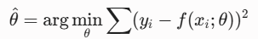
- 訓練均方誤差 (Train MSE)：模型在訓練集上的平均表現。
- 測試均方誤差 (Test MSE)：模型在全新、沒看過的測試集 (D_{Te}) 上的平均表現。這才是評估模型好壞的真實指標！
2. 模型的彈性與「過擬合」
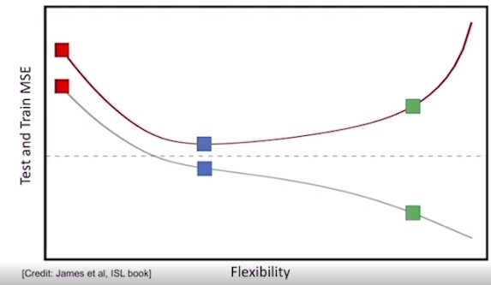
我們通常有一系列的候選模型（例如：1次多項式、2次多項式...到 d 次多項式），模型的次數越高，彈性（Flexibility）就越大。
- 訓練誤差（藍線）：隨著模型越來越有彈性，它能更完美地迎合訓練數據，因此訓練 MSE 會單調遞減（越來越低）。
- 測試誤差（紅線）：會呈現一個 U 型曲線。
  - 太僵硬（低彈性）：模型太簡單，無法捕捉數據規律，此時偏差（Bias）很高（欠擬合，Underfitting）。
  - 太放飛（高彈性）：模型太複雜，連訓練集裡的雜訊都學進去了，此時變異數（Variance）很高（過擬合，Overfitting）。
  - 黃金交叉點：測試 MSE 的最低點，就是我們追求的「最佳彈性」。
3. 驗證集方法（Validation Set Approach）
在現實中，我們通常只有一包標記好的數據，沒辦法憑空生出測試集。為了估計 Test MSE，我們需要「留一手」，這就是再抽樣方法（Resampling Methods）。影片介紹了第一種：驗證集方法。
具體步驟：
- 隨機二分：將原始數據隨機分成兩份：訓練子集 (D_Ts) 和 驗證子集 (D_Vs)（通常是一半一半）。
注意：不能直接從中間切開，必須隨機抽樣，以避免相鄰數據之間有時間或空間上的相關性。
- 訓練模型：只用 D_Ts 的數據去跑優化，算出最佳參數 hat{θ}
- 計算驗證誤差：用這組參數去預測 D_Vs 的數據，計算出來的 Validation MSE，就是我們對真正 Test MSE 的估計值。
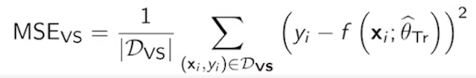

4. 實例分析與驗證集缺點
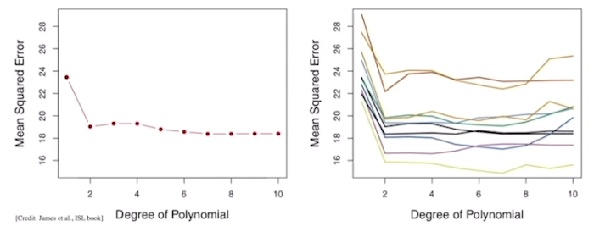
影片用了一個汽車數據集（用馬力 Horsepower 預測每加侖哩數 MPG）來做實驗，比較不同多項式次數（Degree, d）的效果：
- 手肘法則（Elbow Method）：從圖表來看，當次數從 1（線性）變到 2（二次方）時，誤差大幅下降；但從 2 之後，誤差下降就不明顯了。雖然 7 次多項式可能誤差更低一點點，但基於「簡單且好解釋」的原則，選 2 次多項式最好。
⚠️ 驗證集方法的致命缺點
如果我們把上述的「隨機二分法」重複做 10 次（每次抽到的訓練集都不同），畫出來的 10 條誤差曲線會長得非常不一樣（高度波動）。這帶出了它的三個主要缺點：
- 高變異性（High Variability）：估計出來的測試誤差，非常容易受到「當初是怎麼隨機切分數據」的影響。
- 浪費數據：只有一半的數據拿來訓練，當數據量本來就少時，模型可能根本學不飽。
- 高估測試誤差：因為訓練數據變少了（少了一半），訓練出來的模型實力受限，導致算出來的驗證誤差通常會比實際的 Test MSE 還要高。
總結來說：這段內容是在為後面的 K折交叉驗證（K-fold Cross Validation） 和 自助法（Bootstrap） 做鋪墊，因為驗證集方法雖然直觀，但缺點太多，所以我們才需要更進階的方法！

▶️ K-fold cross-validation (9:35)
1 Attempt Quiz: K-fold Validation
In this video, we are going to cover a second resampling technique called K-fold cross-validation. In K-fold cross-validation, we're going to consider a data set, D, and we will take the following steps. In the first step, we're going to randomly partition the available data set into K parts of almost equal size. We will denote these parts D1 up to Dk, and the resulting sizes will be denoted N1 to Nk. In this partition process, we will have a collection of points. So, for example, assume we have N points, and we will partition this collection of N equal to 9 points into, for example, K equal to 3 different parts of equal size. We will denote these parts by D sub 1, D sub 2, D sub 3. And the sizes will be N1=3, N2=3, N3=3. To fill in this part, we will follow a process similar to the one we use in the validation set approach. Essentially, we will start filling up these entries by randomly selecting points, from the original data set. For example, we'll start by picking an index between 1 and 9, maybe 6, and we'll put it in the first entry. We'll pick a second random index, maybe 8, and then we keep filling up these entries completely at random. So, this process will result in a random partition of the original data set into k parts of equal size.
Then we will move on to the second step. In here, we're going to have an iterative step, where the small k will go from one to capital K, the total number of partitions, and we'll take the following two steps. In the first step, we're going to train our model using the data in D minus a subset Dk. So, for example, for k=1, we're going to train our model using the data in the red squares. So, the red subset is called D minus D sub 1. And we will use this red subset to run a training minimization, in which we will minimize the RSE associated to this set D minus Dk. And this will result in an estimated vector of parameters theta hat for partition 1.
After we trained theta hat, using the subset D minus D1, we'll move on to step two in which we will predict the test MSE, using the left-out part D sub 1, which in this particular case, is the set inside the green rectangle.
So, using D sub 1, we will compute the RSE, using the theta hat that we computed in the previous step, and we will normalize by the number of points in D1.
The resulting value is going to be the mean square error for the first pass in this loop. To clarify this process, let me repeat for the second step. So, for example, going to k=2, we will go to step 2.1, and we will train with the subset D-D2, which is the subset of points inside the red rectangles. We will repeat the training process. We will obtain theta hat in the second pass, namely theta hat sub 2, and we will use theta hat sub 2, to compute the MSE in the second pass, using the left-out data part, D sub 2. After repeating this loop capital K times, we will end up obtaining a K-fold cross-validation estimate of the test MSE given by the expression at the end of this slide. So, essentially, this estimate is going to be a summation of the MSEs obtained in each pass of the loop weighted by the fraction of points in the left-out subset of the data.
Moving on to a numerical example, we're going to consider in the figures below, two different K-fold cross-validations, a 10-fold cross-validation where we split our data set into 10 different parts. And another example called N-fold cross-validation, where N points in our data set will be split into N different parts. In other words, each point in the data set will be its own partition. This is a technique that's called leave one out cross-validation. Okay, starting from the numerical results obtained from the 10-fold cross-validation, we observe that by running different random partitions of the dataset, will result in an evolution of the test MSE versus the degree of the polynomial fading that are very close to each other. So, in this particular case, each line in here will be computed using a different random split of the data set into 10 different partitions.
In the case of N-fold cross-validation, each point in the data set will represent its own partition. Therefore, we don't need to randomly split the data set into k different parts. We'll use subsets of N minus 1 points to train our model, and we'll use the left-out sample to perform validation. We will repeat this process N times, and we'll compute the average of the resulting values, to reach to this estimate of the test MSE. We've said that for 10-fold and N-fold cross-validation, the optimal flexibility is around polynomials of degree 2.
We can now move on to describe the advantages of K-fold. The first one, is that as we see in the figures above, the estimates of the test MSE are less volatile and less dependent on the particular random split used in our algorithm.
It also utilizes more observations in training. Essentially, during the training process, we're going to use k-1, out of the k subsets in which you partitioned the original data set. And finally, it provides a less overestimated test MSE.
We can now move on to describe the details of K-fold cross-validation for the classification setup. In particular, we're going to consider a dataset, D, where we have pairs of inputs and outputs. But in this particular case, those outputs are part of a discrete dataset. Where this dataset represent possible labels.
To run K-fold cross-validation, we're going to run the three steps below. The first step is identical as the one we did in the regression setup. In particular, we will have a data set D that we will split into k random subsets.
In the second step, we will use k-1 of these subsets for training.
And in the case of classification, we're going to have to use a different error function. So, the particular error function that you want to minimize, is the misclassification rate of your classifier. In here I'm using a slightly different optimization. So, instead of minimize the misclassification rate, I'm going to maximize the number of points that are correctly classified. So if you look into this equation, we're going to have summation over all the points in the training subset of a function delta, so this is the direct delta function that takes a value, 1, if the argument is 0, and 0 otherwise. Therefore, the term inside the summation will be 1, only when the output of your classifier is equal to the actual output of the ith point. And if you sum over all the points in the dataset, what you're really doing is counting how many points in that subset your classifier is able to label correctly. By maximizing this summation, we'll obtain an estimate theta hat sub k for the parameters of the classifier.
Then we move on to the next step, where we will use the left-out subset to compute the misclassification rate in that left-out part. Looking at the question below, we have a summation over the left-out subset of terms that count how many points in that subset your classifier is able to correctly label. Therefore, the result of the summation is equal to the total number of points in the left-out subset that are correctly classified. Since the total number of points in that subset is equal to Nk, the term in the bracket will count how many points you misclassified in that subset. If you divide the number of misclassified points by the total number of points, you will get the misclassification error rate for the kth partition. Finally, putting all these terms together, the misclassification error rate, will be the weighted sum of those estimates weighted by the fraction of points in each one of the partitions.

這段進入了機器學習中非常核心且實用的再抽樣技術——K折交叉驗證（K-fold Cross-Validation）。它完美解決了前面「驗證集方法」產生的變異數過大、浪費數據等缺點。
以下為你將內容拆解為四大核心區塊，並區分迴歸（Regression）與分類（Classification）兩種情境：
1. K折交叉驗證的核心機制（以迴歸為例）
K折交叉驗證的核心思想是：不把數據死板地一分為二，而是輪流讓每塊數據都當一次驗證集。
執行步驟：
- 隨機分群：將含有 N 個樣本的原始資料集D，隨機切分成 K 個大小幾乎相等且互不重疊的子集（稱為 Fold，標記為 D1, D2, …., DK）(size: N1, N2, …, NK)
- 迭代循環（從 k=1 到 K）：
  - 訓練：抽出第 k 個子集（Dk）當作驗證集，用剩下的 K-1 個子集（記作 D \ Dk, remove kth part）來訓練模型，得到該輪的最佳參數 hat{θk}
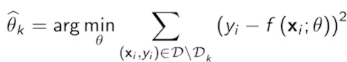
  - 驗證：用剛訓練好的 hat{θk} 去預測被留下來的 Dk，計算出這一輪的均方誤差 MSE_k
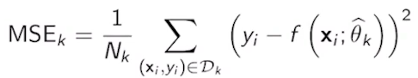
- 加權平均：當循環跑完 K 次後，把每一輪的 MSE_k 依據數據比例做加權平均，得到最終對測試誤差（Test MSE）的估計值：
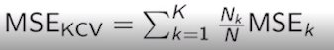
2. 兩種特例與實驗結果

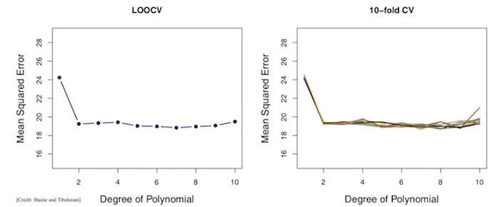
影片中提到了兩種常見的 K 值選擇：
- 10折交叉驗證 (10-fold CV)：將數據分成 10 份。即使你重複做幾次不同的「隨機 10 等分」，算出來的測試誤差曲線（隨著多項式次數 d 變化的曲線）都高度重合且穩定。這說明它克服了驗證集方法隨機性太高的缺點。
- 留一法交叉驗證 (LOOCV, Leave-One-Out CV)：當 K = N（樣本數）時的特例。也就是說，每次只留下一個樣本(不是一個subset)做驗證，用其餘 N-1 個樣本訓練。
  - 優點：完全不需要隨機切分，因為切分方式是固定的；而且訓練集非常大（N-1），估計非常精準。
無論是 10-fold 還是 LOOCV，在汽車數據集的實驗中，都同樣指向多項式次數 d=2（二次方）是最佳的彈性選擇（手肘點）。
📊 K折交叉驗證的優點總結：
- 低變異性（Less Volatile）：評估結果不會因為某一次運氣不好切錯數據而大受影響。
- 充分利用數據：每次訓練都用到了 (K-1)/K 的數據（例如 10-fold 就用了 90% 的數據），比驗證集方法（只用 50%）更充分。
- 更準確的誤差估計：不會像驗證集方法那樣嚴重高估測試誤差。

3. 分類問題（Classification）中的 K折交叉驗證
當預測的目標不是連續數值，而是離散的標籤（Label）時，核心步驟（隨機切分、輪流訓練）完全一樣，但誤差的計算方式（指標）改變了。
步驟 3.1：參數訓練（最大化正確分類數）
在分類中，我們不計算殘差平方和（RSE），而是利用脈衝函數（Dirac Delta Function, δ）來統計答對的題數。
- 當模型預測與真實標籤一致時，δ = 1；不一致時 δ = 0

- 在訓練階段，我們的目標是找到一組參數 hat{θk}，能夠最大化訓練集（D \ Dk）中被正確分類的樣本總數。
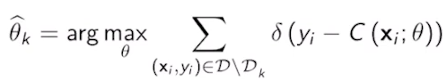

步驟 3.2：驗證階段（計算錯誤率 Misclassification Rate）
在留下來的驗證集 Dk 上，我們先算出「答對的題數」，接著用總題數 Nk 減去答對題數，就會得到答錯的題數：
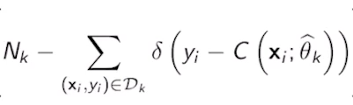
將答錯題數除以該組總人數 Nk，就得到第 k 折的錯誤率（Error Rate）。
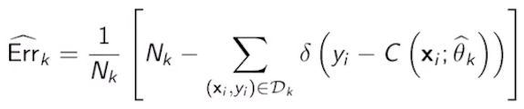
最終整合
同樣地，將 K 次循環得到的錯誤率進行加權平均，就能得到該分類器最終的整體錯誤率估計值。
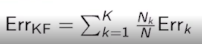

核心觀念整理：
K折交叉驗證的核心就是「輪流作東」。迴歸看的是誤差（MSE）的平均；分類看的是錯誤率（Misclassification Rate）的平均。

3. Bootstrap
▶️ Bootstrap (10:18)
Let me start this video by recapping the training process of a parametric model. In particular, consider a parametric model f of x_i, with an unknown vector of parameters Theta, as well as a training dataset formed by N input and output pairs. In the field of statistical learning theory, in order to statistically analyze our results, we assume that each sample is randomly drawn from a joint PDF, f_XY. We have also seen before that the estimated parameters, Theta hat, are the result of an optimization problem where we minimize the RSE over the training dataset. Notice that because x and y's are random variables, the result of the minimization problem can also be interpreted as a random vector. In other words, Theta hat depends on data points that are random variables themselves. Furthermore, the estimated output for a given input x, will also be a random variable because Theta hat is random itself. As a bottom line, since our estimates are random variables, we would like to quantify the uncertainty of these estimated parameters as well as the output. To elaborate on the ideas that I mentioned in the previous slide, let's consider an unrealistic experiment or an unrealistic approach to quantify uncertainty. I'm going to assume that instead of having a single training dataset, I'm going to have the means to retrieve M independent training datasets that I'm going to denote as D_training superm, where m will be from one to capital M. Notice that this step is in general unrealistic because collecting data is typically an expensive process and you will have only one dataset in practice. Now, continuing with this unrealistic experiment, we're going to use this M datasets to compute M independent estimates of the unknown parameters that we're going to denote as Theta hat superm, where the subscript denotes the dataset used in our estimation. Using this M estimates, we will visualize and study the uncertainty of our model. In other words, we study how robust our estimates are to randomness in the data. Let's move on to illustrate this idea numerically. In particular, we consider a numerical illustration where we will have capital M equal to a thousand training datasets, where each dataset is generated according to an additive linear model with Beta_0 equal to 0 and Beta_1 equal to 0.8. These are two values that nature is using to generate the data, but they are unknown to us. Now, using the techniques we studied for linear regression, we can compute a thousand different estimates, each one of them coming from each one of the 1,000 training datasets available. In the figure below, I show a histogram of these 1,000 estimates of Beta_1. Essentially, we see that the mean of this histogram is 0.799, which is extremely close to the true value 0.8, that nature is using to generate the data. Also, the standard deviation of this bell curve is 0.058. Now, using the mean and the standard deviation, we could also build a 95 percent confidence interval that are included in this bracket. This particular approach is very unrealistic and inefficient, because in the case of linear regression, we have explicit formulas to find estimates of the standard deviation from one single dataset. However, there are other regression and classification techniques in which the standard deviation of the parameters of the model cannot be computed in closed form from one dataset. Also, let me remark that this approach is unrealistic, because in practice, we don't have access to M independent training datasets. In the real world, collecting data is typically an expensive process and collecting M training datasets will multiply by M the cost of this process. In this context, we can use the bootstrap, which will allow us to generate M artificial datasets given a single dataset. This will be achieved by following these steps. In the first step, we're going to run a loop where we will go for m equal 1 to capital M. In the first step, we're going to sample N random observations from D with replacement. To illustrate this idea, let's consider a dataset with 10 points. Therefore, according to step 1.1, I'm going to start sampling points uniformly at random with replacement, meaning that every now and then I could pick a point twice. For example, eight. In other words, I sample and I put the sample back into the sampling pool. So we will include this N observations into an artificial dataset that we will denote by D_m superB. So this is D_1 super bootstrap, and this will be the original dataset. This dataset is called a bootstrap sample and it's going to use in the next step to train a model fx Theta. Essentially, we're going to minimize the RSE associated to that bootstrap sample and we will store the optimal value of the parameters into new variable Theta hat_m superB. We will repeat this loop n times. Essentially we will have capital M bootstrap samples with different points as well as M bootstrap estimates of our unknown parameters. Using these estimates, we can now move on to the next step in which we will compute the empirical average of this estimates according to this formula and we will use this empirical mean to compute an estimation of the standard deviation according to the bootstrap sample. So the result of this square root will be an estimate of the standard deviation of Theta hat. Let me show you a visual illustration of the bootstrap process. In particular, we're going to be given a dataset retrieved from an additive linear model. So the samples in our dataset are these blue circles. Now, for m equal 1 to capital M, we're going to sample with replacement points from this original data set. So in this first bootstrap sample, the red crosses represent points in the original dataset that are included in that particular bootstrap sample. I have also left the blue circles in the original dataset, but those blue circles are not part of the bootstrap sample. I just want for us to see that some of the points in the original dataset are not sampled by the bootstrap sample and also note that some of these red crosses will contain multiple samples. Using these red crosses, we can compute our first estimate of Beta_1 using bootstrap. We can repeat the sampling process, meaning, we can generate a second bootstrap sample resulting on the dataset indicated by red crosses. Again, some of these red crosses will contain multiple samples that are repeated, and from those samples, we will be able to compute a second bootstrap estimate for Beta_1. We'll continue up to the capital M bootstrap sample, which in this particular case is equal to a 1,000 and using these bootstrap sample, we will compute a thousand estimate of Beta_1. In this plot, we include a histogram of the 1,000 estimates of Beta_1 that we obtained from bootstrap samples and you can see that the result is a Gaussian bell that is similar to the one that we obtained when we used a thousand independent datasets. In this slide, I compare the histogram obtained from the unrealistic approach, where I retrieved a thousand different datasets, which is a very costly process with the histogram that we obtained from one simple dataset, but bootstrap a thousand times. You can observe that these two histograms are very close to each other. In particular, the main intervals are both between zero, six, and one. The mean of the bootstrap histogram is equal to 0.773, while the mean of the unrealistic histogram obtained from a thousand different realizations is 0.799. Furthermore, the standard deviation of the bootstrap histogram is 0.055, which is very close to 0.058, which is the value obtained from the unrealistic approach. So this numbers illustrate the effectiveness of the bootstrap to estimate the uncertainty, in particular, the standard deviation of the parameters in our model. So this finalizes the seventh week of the course. Before we move on to the next topic, I strongly suggest that you read Chapter five in the book, An Introduction to Statistical Learning, and work through the assessments. I'll see you next week.

這段介紹了機器學習與統計學中極為強大且漂亮的統計工具——自助法（Bootstrap）。它的核心目的是為了解決一個現實痛點：「在只有一包數據的情況下，如何評估模型參數的不確定性（標準差、信心區間）？」
以下為你將這段內容拆解為三個核心層次：
1. 理想與現實的衝突：如何量化不確定性？
在統計學習理論中，我們訓練出來的模型參數 hat{θ}（例如線性迴歸中的 β1）其實是一個隨機變數。因為數據本身是隨機抽樣來的，數據一變，算出來的參數就會跟著變。
理想狀態（不切實際的實驗）：
如果我們非常有錢、有時間，去自然界中重新收集 M 個（例如 1000 個）完全獨立的訓練資料集。
- 我們可以用這 1000 個資料集(D_{Tr}^{m} for m = 1,2,…M) 算出 1000 個不同的 hat{θm}
- 把這 1000 個值畫成直方圖，會得到一個漂亮的鐘形（高斯）曲線。
- 透過這個直方圖，我們可以輕鬆算出參數的平均值（如 0.799，非常接近真實值 0.8）與標準差（0.058），進而定出 95% 信心區間。
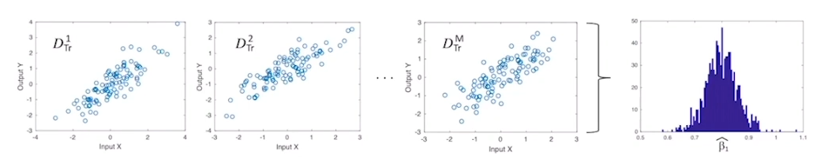
現實困境：
在真實世界中，收集數據非常昂貴。你永遠只有一包資料集。如果沒有公式可以直接導出標準差（例如某些複雜的機器學習模型或分類器），我們該怎麼辦？

2. 自助法（Bootstrap）的核心機制
Bootstrap 的妙處在於：既然不能從自然界生出新數據，我們就把手頭上的這包資料集當作「整個自然界」，從中自我繁殖！
執行步驟：
- 進入循環（從 m=1 到 M）：
  - 有放回抽樣（Sampling with Replacement）：從原本含有 N 個樣本的資料集中，隨機抽取一個樣本，記錄下來，然後把樣本放回去，再抽下一個。重複 N 次。
  - 因為是「有放回」，有些樣本可能會被重複抽到多次（影片中提到的紅叉叉重疊），而有些樣本則完全沒被抽到（留下的藍色圓圈）。
  - 這抽出來的 N 個點就組成了一個人工資料集，稱為 Bootstrap 樣本 (D_{m}^{B})。
  - 訓練模型：用這包人工資料集去跑優化（最小化 RSE），算出一個參數估計值 hat{θ_{m}^{B}}
  - 重複 M 次：通常 M=1000。這樣我們就得到了 1000 個 Bootstrap 參數估計值hat{θ_{m}^{B}}

- 計算標準差：利用這 1000 個估計值，先算經驗平均數，再帶入以下公式算出標準差（標準誤）：
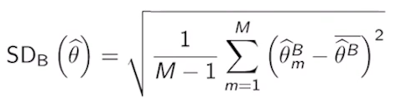
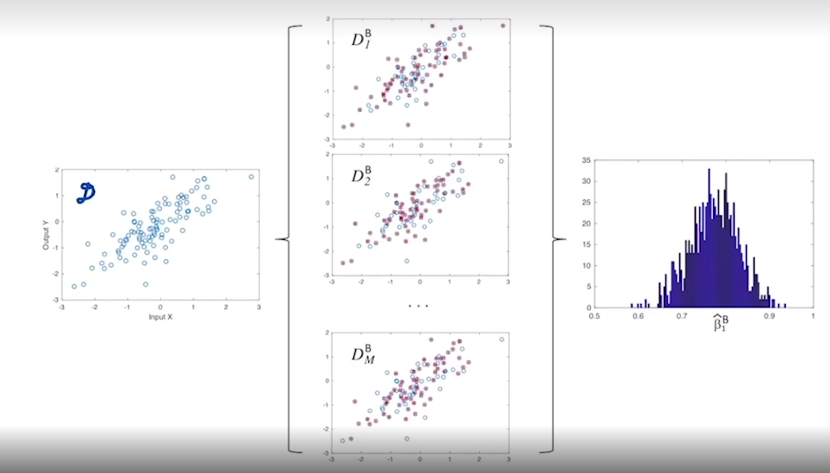
3. 實驗結果對比：它真的有效嗎？
影片最後展示了驚人的對比結果，證明了 Bootstrap 這種「自己抓著頭髮把自己提起來」的方法真的非常精準：
評估指標 | 理想方法（收集 1000 個獨立資料集） | Bootstrap 方法（從單一資料集抽樣 1000 次）
直方圖分布 | 呈現標準高斯鐘形曲線 | 呈現極度相似的高斯鐘形曲線
平均值 (Mean) | 0.799（極接近真值 0.8） | 0.773
標準差 (Std Dev) | 0.058 | 0.055（兩者非常接近！）

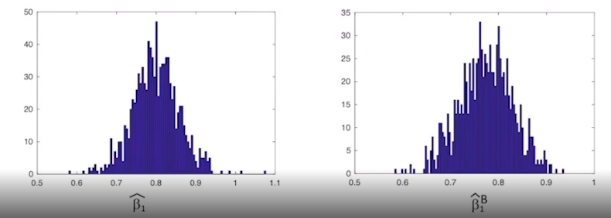

💡 結論
這項實驗證明了 Bootstrap 的巨大價值。它讓你不用花費 1000 倍的成本去收集數據，只需利用電腦的算力在單一資料集上不斷進行「有放回抽樣」，就能精準估計出參數的變異數與不確定性。

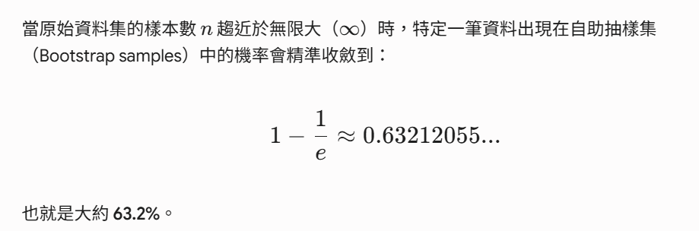
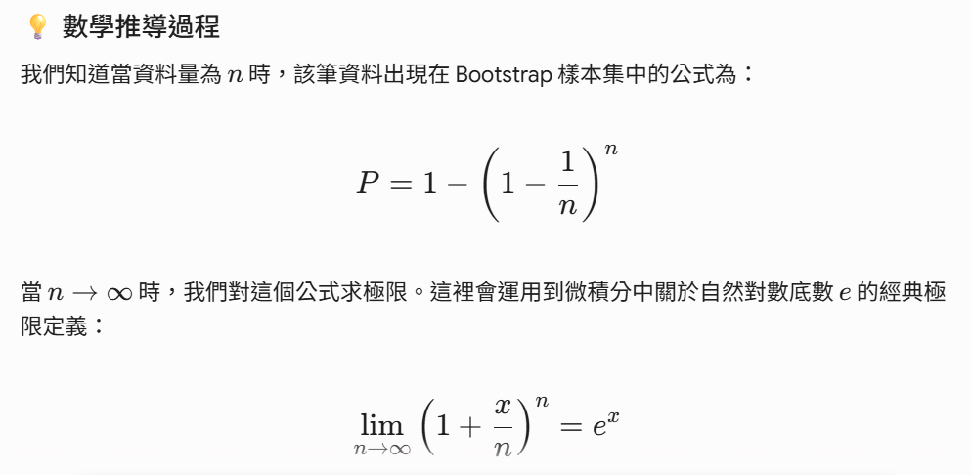
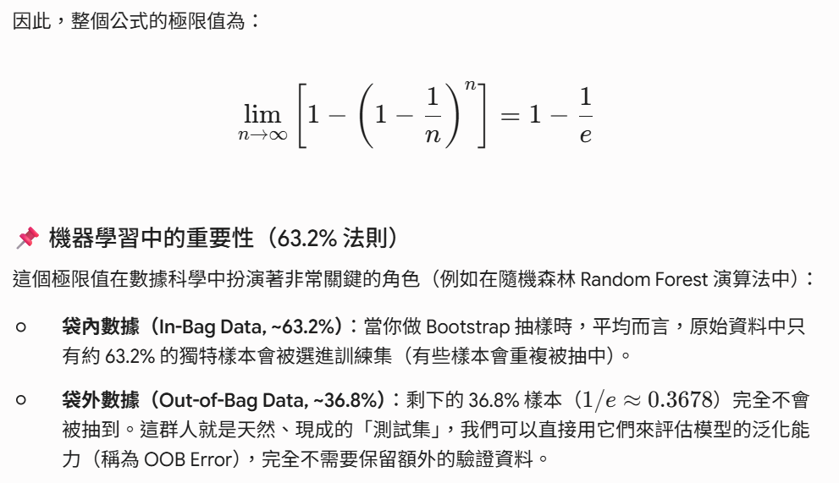
1 Attempt Quiz: Bootstrap
4. Python Lab
▶️ Python Lab: Cross-validation (10:15)
Hello, everybody. Welcome to recitation 5, part 1. In this recitation, we're going to be exploring cross validation using the auto data set. What we're going to be looking at, at the polynomial interaction of horsepower in predicting miles per gallon. To do this, we're going to explore multiple fits, each one adding higher-order terms of horsepower in our model.
Our error will be measured with the mean_squared_error. So in this recitation, we'll be looking at the validation set approach, Leave One Out validation, and K-Fold cross validation. The next recitation, we'll be covering Bootstrap. Let's look at our validation packages. We have ShuffleSplit, LeaveOneOut, cross_val_ score, K-Fold, train_test_split, and for metrics, mean_squared_error. Resample will be used in the next recitation.
So getting started with the auto dataset, we reason with pandas.read_csv, and we remove any missing values with dropna, and then we preview our data with data.head.
So the validation set approach is pretty simple. We split the training set into two parts. One is used for the fit, and the other is used for validation. What we're going to do is we're going to repeat this procedure for 10 different splits, and then we're going to look at the variation in error that we get. If you were paying attention to our library imports, you would have noticed that all of our cross validation packages were imported from scikit-learn. These were built to work very nicely with the scikit-learn linear regression model. However, this linear regression model does not have an easy argument of a formula string that will automatically transform your data into a higher-order polynomials if that's what we want to perform regression on. So we're going to have to do is transform our data ourselves. But we can't just add columns of MPG squared or MPG cubed because that will lead to interaction. What we need to do is perform QR decomposition, and obtain an orthogonal matrix. If you want to understand what this function does better, then these are two really good stack overflow links that we'll go more into detail about that.
Let's just perform an initial linear regression to get a feel for the relationship between MPG and horsepower. To do this, we define our X vector as a horsepower column, our Y vector as a MPG column or model, and then we transform X to a NumPy array with a max degree of 1, and then we call model.fit, passing in our transformed X and our Y. Now note that because this is a scikit-learn linear regression model, we get our fitted values from model.predict passing in our X. Now the degree 1 linear regression model doesn't do a bad job of fitting the data. But it's pretty clear that a higher-order regression models will do a better job.
Now let's perform 10 different splits for each linear regression of degree 1 through 5. To do this, we're going to define a CV method which is K-Fold, and we set the number of splits to be two, shuffle to be true. We want the random state to be different for each time we define the CV method. Now observe that for each exponent in the range of one to five, we update our order array. We define a new transformation of X using the poly function. We will obtain our error as negative one times the mean of the negative_mean_squared_errors for each fold. Here cross_val_score does most of the work for us because we pass in a model, our X and Y arrays and our CV method. We define our scoring, and it runs cross validation for us returning an array of negative_mean_ squared_errors for each fold. Lastly, we update our score with the computed error, and that was all just one trial. So repeat this process 10 times, where each time, we define a new split due to the different random state. Finally we display a box plot where we can see the variation in the mean_squared_error for each degree. We can see that there's a very high improvement in our model from 1-2, not much improvements from degrees 2-4, and then a slight improvement from degrees 4-5. However, notice how the variation of our mean_squared_error across all the 10 trials increases as we increase the degree of our polynomial. In general, we can expect the validation set approach to produce an approximation of the test mean_squared_error that is highly variable. This is due to the high dependence of the mean_squared_error on the specific split used.
Now let's perform Leave One Out cross validation. The Leave One Out algorithm uses n minus 1 samples to train the model, and only one observation is used to validate the model. This procedure is repeated n times, and the errors are averaged. Before we proceed, we are going to split our data into a train and test sets. To do this, we're going to use the train_test_split function, and we're going to specify a test size of 20 percent of the data. We're going to save the testing data for later, and we're just going to perform Leave One Out cross validation on our training data. Now to obtain MSE approximations for each degree polynomial, we proceed similarly as before, except we only perform one trial. We loop through each degree polynomial, specifying a new transformation of X of that degree polynomial. Then we specify our error as negative 1 times the mean of a cross val score. This time, our CV method is Leave One Out instead of K-Fold.
As we can see, there's a large improvement from the Degree 1 to Degree 2 polynomials, not much change between the Degree 2 and Degree 4 polynomials, and a slight improvement from Degree 4 to Degree 5 polynomials. Similar to what we saw with the validation set approach.
The advantages of Leave One Out cross validation over the validation set approach are that it provides a less volatile estimate of the test mean_squared_error. It uses more samples to train our model, which in turn results in a less overestimated mean_squared_error.
Lastly we've performed K-Fold cross validation. K-Fold cross validation splits the data into k baskets, and k minus 1 of these baskets are used to train, and one is used for testing. This procedure is repeated k times, where each basket has a turn to act as a testing set. The errors are computed for each of these K test sets, and then averaged. We can see when K equals n, then K-Fold cross validation is identical to Leave One Out. In this example, we're going to be using K equals 10.
Additionally we're going to want to look at the variation, the approximated test MSE. To do this, we're going to compute 20 trials for each order of degree polynomial.
Each trial, note that we redefine our CV method to use a different random state so that we obtain a different split. This procedure results in the following boxplots.
Once again, we see a large improvement from Degree 1 to Degree 2 polynomials. Not much change between Degree 2 and 4, and a very slight improvement from Degrees 4-5. Note that because K-Fold cross validation is a more general version of Leave One Out cross validation, that it has all the same advantages over the validation set approach the Leave One Out cross validation does. Note that the spread of MSEs for each degree of polynomial is much less than what we saw for the validation set approach. An advantage the K-Fold cross validation has over Leave One Out cross validation is that it produces an MSE approximation that is less variable. A disadvantage, however, is that it overestimates the test MSE slightly more than Leave One Out cross validation and uses less samples to train the model. In general, the advantages that K-Fold cross validation and Leave One Out cross validation have over the validation set approach make them a more attractive validation tool.
However, note that for very large datasets, the computational expense may not be feasible, in which case, we revert back to the validation set approach, or we consider bootstrapping methods, which we will cover in the next recitation.

這段是關於機器學習中模型驗證（Model Validation）的 Python（Scikit-learn）實作課堂筆記。這次課堂使用著名的汽車數據集（Auto Dataset），目標是利用「馬力（Horsepower）」來預測「每加侖哩數（MPG）」，並比較不同次數的多項式模型（1次到5次方）在三種驗證方法下的表現。
以下為你整理程式碼背後的實作邏輯與核心知識點：
1. 資料準備與多項式轉換的陷阱
在實作開始前，有兩個關鍵的資料處理步驟：
- 資料清理：使用 pandas.read_csv 讀入資料後，必須立刻用 .dropna() 刪除缺失值，確保後續矩陣運算不會出錯。
- 正交多項式（QR 分解）：
在 Scikit-learn 中，如果直接將 Horsepower 加上平方項（X^2）或立方項（X^3），會導致特徵之間產生極高的共線性（Multicollinearity）與交互作用。
解決方案：課堂中提到必須進行 QR 分解（QR Decomposition），將特徵矩陣轉換為正交矩陣（Orthogonal Matrix）。這樣做能讓各個高次方項之間彼此獨立，回歸模型才會穩定。

2. 三種驗證方法的實作與比較
📌 方法一：驗證集方法（Validation Set Approach）
- 程式實作：使用 KFold(n_splits=2, shuffle=True)。將數據隨機一分為二（50% 訓練，50% 驗證）。
- 實驗設計：重複進行 10 次隨機切分（10 Trials），每次使用不同的 random_state。
- Scikit-learn 核心函式：
cross_val_score(model, X, Y, cv=CV, scoring='neg_mean_squared_error')
注意：Scikit-learn 預設的評分機制是「越大越好」，所以回傳的是負的均方誤差（Negative MSE）。我們必須將結果乘以 -1 才能得到真正的正值 MSE。
- 結果與缺點：
畫出盒狀圖（Boxplot）後發現，隨著多項式次數增加，10 次實驗之間的 MSE 變異數（散佈範圍）變得非常大。這證實了驗證集方法的缺點：高度依賴「數據是怎麼切分的」，結果極不穩定。
📌 方法二：留一法交叉驗證（LOOCV）
- 程式實作：將 cv 參數換成 LeaveOneOut()。
- 實驗設計：先用 train_test_split(test_size=0.2) 拔出 20% 的測試集保留到最後。只對剩下的 80% 訓練資料進行 LOOCV。
- 特點：因為切分方式是固定的（每次輪流留下一筆），所以只需要跑 1 次試驗（1 Trial），不需要像驗證集方法那樣重複做 10 次。
- 優點：比驗證集方法更穩定（波動小）、訓練樣本多（N-1），因此算出來的 MSE 比較不會被高估。
📌 方法三：K折交叉驗證（K-Fold Cross Validation）
- 程式實作：使用 KFold(n_splits=10, shuffle=True)，也就是經典的 10-Fold CV。
- 實驗設計：為了觀察 10-Fold 的穩定度，課堂中重複進行了 20 次隨機切分（20 Trials），每次改變 random_state。
- 結果與 LOOCV 的對比：
  - 更低的變異數（Less Variable）：10-Fold 算出來的 MSE 散佈範圍（盒狀圖的寬度）比驗證集方法小非常多，甚至在統計性質上，其變異數有時比 LOOCV 還要低（因為 LOOCV 每次訓練的模型高度相關）。
  - 些微的偏差（Slightly Overestimated）：因為每次只用 90% 的數據訓練（LOOCV 用了幾乎 100%），所以 10-Fold 對測試誤差的估計會比 LOOCV 稍微偏高（保守）一點點。
3. 共同的模型結論：該選幾次方？
不論使用哪一種驗證方法，10次或20次試驗的結果都呈現相同的趨勢：
- 1次方 2次方：誤差（MSE）大幅度下降，說明馬力與油耗之間有明顯的二次方（曲線）關係。
- 2次方 4次方：誤差幾乎沒有進步。
- 4次方 5次方：只有極微幅的下降，但伴隨而來的是模型複雜度增加。
最終決策：根據奧卡姆剃刀原則（選擇簡單且好解釋的模型），2 次多項式模型（Quadratic Model） 是最佳選擇。
4. 核心總結與下一步
最後助教給出了一個非常重要的實務建議：
驗證方法 | 準確度（偏差/變異） | 計算成本（運算速度） | 適用場景
Validation Set | 誤差易高估、不穩定 | 🚀 極快 (只需跑1次或幾次) | 大數據集、模型極其複雜時
LOOCV (K=N) | 準確、最無偏 | 🐌 極慢 (數據多大就要跑幾次) | 小數據集
K-Fold (K=10) | 兼具準確與穩定 | ⚖️ 中等 (固定跑 K 次) | 最推薦的通用方法
⚠️ 大數據的痛點：當資料量極大時，K-Fold 或 LOOCV 的計算成本會高到無法負荷。這時候我們就必須退回使用「驗證集方法」，或者使用下一堂課要講的 自助法（Bootstrap）。
💡 註：為什麼講稿說 K-Fold 比 LOOCV 的 Variance 還要低？ 因為 LOOCV 每次訓練的模型所用的資料有 n-2 筆是重疊的，這導致這 n個模型高度相關（Correlated）。統計學上，多個高度正相關的隨機變數取平均，其方差（Variance）會比不相關的變數取平均還要大。因此 K=5或 10 的 K-Fold 通常能提供方差最低、最穩定的預估測試誤差。

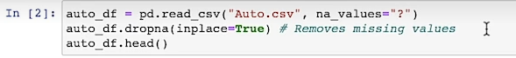
- pd.read_csv("Auto.csv")：讀取同一個資料夾底下名為 Auto.csv 的 CSV 檔案，並將它轉換成 pandas 的資料框架（DataFrame），命名為 auto_df。
  - na_values="?"（關鍵點）：這是非常貼心的設定。在原始資料中，有些缺失值（欄位空白）可能不是真正的空白，而是被填上了問號 "?"。這個參數告訴電腦：「只要在表格裡看到問號 ?，請一律幫我視為遺失值（在 Pandas 中會顯示為 NaN）」。
- dropna()：這個函數會檢查表格內所有的橫列（Rows），只要那一個橫列中有任何一個欄位是 NaN（也就是剛才那些被辨識出來的問號或空白），整橫列就會被刪除。
  - inplace=True：這個參數代表「直接在原地修改資料」。如果不加這個參數，dropna() 只會回傳一個乾淨的複本，原本的 auto_df 還是髒的；加了 True 之後，修改會直接套用到 auto_df 本身，不需要再寫一次 auto_df = auto_df.dropna()。

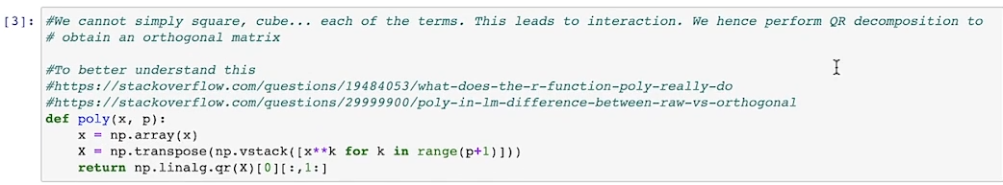
- 新函式 poly(x,p)
  - 輸入參數：x 是原始的特徵向量（例如汽車的馬力 horsepower），p 是你希望最高達到的多項式次方數（Degree，例如 p=5 代表要算到 x^5）。
  - 第一步將輸入的資料強制轉換成 NumPy 的 Array 結構，方便後續進行矩陣運算。
- X = np.transpose(np.vstack([x**k for k in range(p+1)]))
  - 這裡使用列表推導式（List Comprehension）生成從 0 次方到 p 次方的矩陣。
  - 當 range(p+1) 執行時，k 會是 $0, 1, 2, …, p
  - np.vstack([...]) 會將這些次方項垂直堆疊（Vstack），變成一個矩陣，此時它的形狀是 (p+1, 樣本數)。
  - 經過 np.transpose(...)（轉置）後，矩陣 X 變成了經典的 Vandermonde 矩陣，形狀為 (樣本數, p+1)。矩陣的各行欄位分別代表：

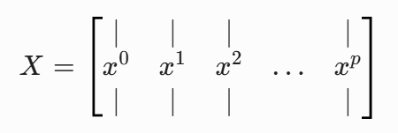
- np.linalg.qr(X)：對剛才建立的 Vandermonde 矩陣進行 QR 分解。數學上，它會將矩陣分解為 X = Q ∙ R：
- Q 矩陣：一個正交矩陣（Orthogonal Matrix），這意味著 Q 的任意兩個不同欄位（Columns）之間的內積皆為 0（彼此垂直、完全不相關）。
- R 矩陣：一個上三角矩陣（Upper Triangular Matrix）。
- [0]：np.linalg.qr() 會同時回傳 (Q, R) 兩個矩陣，這裡的 [0] 代表我們只要 Q 矩陣。
- [ : , 1 : ] 的意思就是：
  - 「對 Q 矩陣進行切片，列（Rows）全部都要（冒號 :），但欄（Columns）從 Index 1 開始往後拿（1:），也就是故意把 Index 0 的常數項丟掉。」
  - 因為 Q 矩陣的第一欄（Index 0）對應的是常數項 x^0（全為 1 的行），而線性回歸模型（如 LinearRegression()）通常會自動幫我們加上截距項。為了避免重複，這裡使用 Python 切片（Slicing）把第一欄切掉，只保留從 1 次方到 p 次方對應的正交特徵欄位。
  - 不可以在一開始就生成x^1, x^2,…,x^p的矩陣就好?? 如果一開始不把 x^0（常數項）放進去一起參與 QR 分解，那麼後面提煉出來的 x^1, x^2, …, x^p 就無法與「常數項」保持正交！
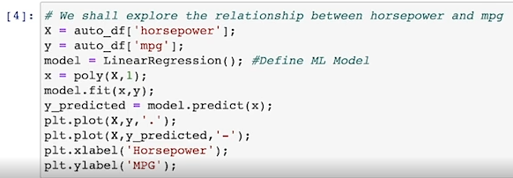

- X：自變數（特徵），即汽車的馬力。
- y：應變數（標籤），即汽車的油耗（每加侖英里數）。
- model = LinearRegression()：從 sklearn 引入線性回歸演算法，初始化一個回歸模型物件
- x = poly(X, 1)：調用你們前面寫的 poly 函數。注意它傳入的最高次方是 1。這代表它會把馬力拿去建立含有 [x⁰, x¹] 的矩陣，並做 QR 分解後切掉常數項。因為最高只有 1 次方，所以這裡提煉出來的 x 其實就是經過縮放、去中心化後的純 1 次方馬力特徵。
- model.fit(x, y)：正式訓練模型。讓電腦去學習 x（馬力）與 y（油耗）之間的最佳直線公式（找出最完美的斜率與截距）。
- y_predicted = model.predict(x)：產生預測值。訓練好之後，把馬力特徵 x 再次丟進去，讓模型吐出它「預測」出來的油耗值，存進 y_predicted。
- 後面這四行使用 matplotlib.pyplot 來繪製圖表：
  - plt.plot(X, y, '.')：畫出真實數據的散佈圖。第三個參數 '.' 代表點的樣式（Dot），畫面會呈現出一個個真實汽車資料的藍色圓點。
  - plt.plot(X, y_predicted, '-')：畫出模型的預測線。第三個參數 '-' 代表畫實線（Solid Line）。因為這是 1 次方線性回歸，所以這會是一條貫穿資料點的斜直線。
  - plt.xlabel(...) 與 plt.ylabel(...)：幫圖表的 X 軸貼上「Horsepower（馬力）」標籤、Y 軸貼上「MPG（油耗）」標籤。

Validation Set Approach 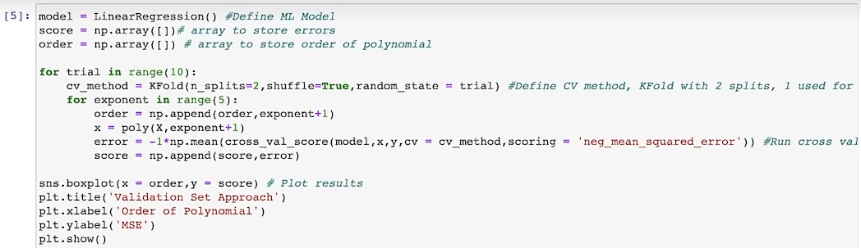

外迴圈：10 次獨立隨機切分實驗（10 Trials）
- range(10) 讓這段實驗重複跑 10 次。
- 重點（n_splits=2）：這裡雖然用 KFold，但因為設定拆成 2 折，在統計上它完全等同於 Validation Set Approach（50/50 對半切）：一半拿來訓練，一半拿來驗證。
- 精妙之處（random_state=trial）：每一次外迴圈的 trial 分別是 0, 1, 2, …., 9。因為隨機種子（Random State）不同，這 10 次實驗每次切分出來的「訓練集」和「驗證集」名單都完全不同。
內迴圈：挑戰 1 到 5 次方多項式（Degrees 1 to 5）
- range(5) 產生的 exponent 是 0, 1, 2, 3, 4，所以 exponent + 1 代表多項式次數分別為 1、2、3、4、5 次方。
- poly(X, exponent + 1)：調用前面寫好的 QR 分解正交化函數，把馬力轉換成對應次方的正交特徵矩陣 x。
- cross_val_score：這台機器會自動幫我們把資料對半切（因為 cv=cv_method），用第一半訓練、第二半測試算一個 MSE；再用第二半訓練、第一半測試算另一個 MSE，最後回傳這兩個 MSE 的陣列。
- 為什麼要乘以 -1？：因為 Scikit-learn 的底層設計邏輯是「評分指標（Scoring）越高越好」，所以它把均方誤差（MSE）加了負號，叫做 neg_mean_squared_error（負均方誤差）。為了還原成我們看得懂的、大於 0 的正數 MSE，必須在前面乘以 -1。
- np.mean(...)：把對半切的兩次驗證誤差取平均，得到這一輪的代表 MSE，並存入 score 陣列。
Leave One Out Cross Validation
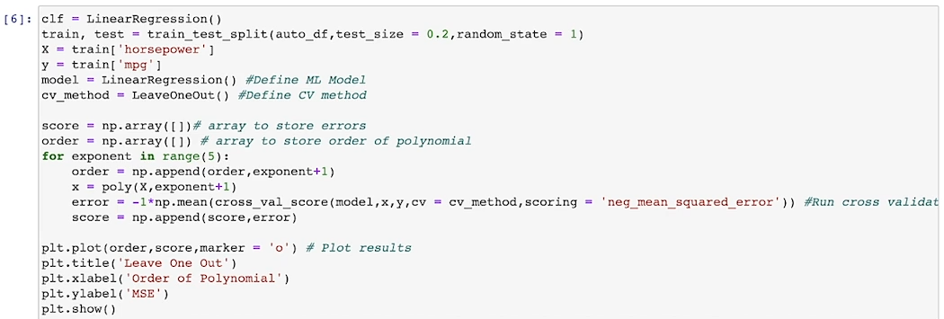
步驟一：保留 20% 的數據當作「最終考卷」
- train_test_split(..., test_size = 0.2)：這是非常標準的機器學習實務。它把整張表格隨機切成兩份：80% 的訓練集（train） 與 20% 的測試集（test）。
- 重點：後面的 LOOCV 交叉驗證，完全只在 80% 的 train 數據內部自己玩。那 20% 的 test 資料被完好地封存起來，留待未來測試模型的泛化能力。
- 為何要切20%數據出去?? 在機器學習的專案中，數據通常被分為三個考卷：
- 訓練集（Training Set）：上課的課本。
- 驗證集（Validation Set）：學校的模擬考。用來調整模型（例如決定要用 2 次方還是 5 次方多項式）。
- 測試集（Test Set）：最後的大學聯考（真正的戰場）。
- 如果不切 20% 出去，直接用 100% 的原始數據跑 LOOCV，依然可以得出「2 次方模型最好」的結論。但是，他將永遠失去評估這個模型「真正泛化能力（Generalization）」的機會。因為你已經用這 100% 的數據來「挑選次數（選了 2 次方）」了，這在統計學上叫做資料洩漏（Data Leakage）。

步驟二：宣告 LOOCV 驗證機制
- 這裡將驗證方法定義為 LeaveOneOut()。
- LOOCV 的運作原理：假設你的 train 資料集有 N 筆資料。模型會重複跑 N 輪。每一輪都只拿 1 筆資料當驗證，其餘 N-1 筆資料拿來訓練。跑完 N 輪後，把這 N 個單獨的誤差取平均。
步驟三：單一迴圈挑戰 1 到 5 次方
- 發現了嗎？這裡外面沒有包 for trial in range(10) 了！ 只有一個簡單的 for exponent in range(5)。
- 為什麼不需要重複跑 10 次試驗？ 因為 LOOCV 的切分方式是完全固定的（每次就是輪流拿第 1 筆、第 2 筆...到第 N 筆當驗證）。不論你執行這段程式碼多少次，每一次算出來的 MSE 結果都會一模一樣，它沒有任何隨機性（Zero Variance）。
- cross_val_score(..., cv = cv_method)：這台機器這次會在內部瘋狂重複跑 N 次（在 Auto 資料集約有 300 多次），幫你把每一輪那唯一的 1 筆驗證資料的誤差算出來，最後 np.mean 取平均得到該次方的 LOOCV MSE。
步驟四：折線圖繪製（注意：這次不是 Boxplot！）
因為 1 到 5 次方各別都只有唯一一個精準的 MSE 數值，沒有群體分佈，所以助教改用 plt.plot(..., marker='o') 畫一條簡單的折線圖，而不是先前的盒狀圖（Boxplot）。

K-Fold Cross Verification
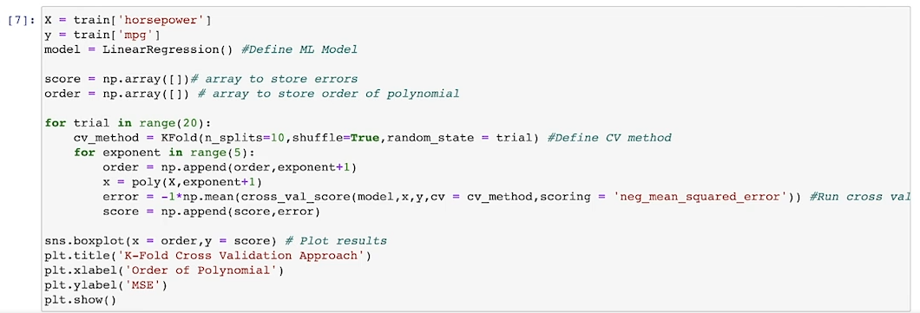
最後一種類型：10折交叉驗證（10-Fold Cross Validation），並且重複執行了 20 次隨機試驗（20 Trials）。
這段 code 的邏輯架構與你前面看過的驗證集方法（Validation Set Approach）極其相似，但內部的核心參數做了關鍵調整。這正是為了展示 K-Fold 交叉驗證如何同時繼承「驗證集方法」與「LOOCV」兩者的優點。
cvmethod = KFold(n_splits = 5, shuffle = True, random_state = trial)
這是一個切割方法 但不會在這時候跑

1. 程式碼核心改變與細節解析
步驟一：定義 K-Fold 切分方式
- 外迴圈跑 20 次（range(20)）：重複做了 20 次不同的隨機切分實驗。
- 關鍵亮點（n_splits=10）：這行是這段程式碼的靈魂。它告訴電腦：把 80% 的 train 資料(拿了上一格切好的 train 變數來用) 均分成 10 個籃子（Folds）。每次輪流拿其中 1 個籃子當驗證集，其餘 9 個籃子合併拿來訓練模型。這個過程重複 10 輪，最後取平均。

步驟二：計算與記錄 MSE
- 內迴圈依然挑戰 1 到 5 次方：使用 QR 分解生成正交特徵矩陣。
- score 與 order 的總長度：因為外迴圈跑了 20 次，內迴圈跑 5 次，所以這兩個陣列最後的總長度是 100（20 x 5 = 100）。也就是說，每一個次方（例如 2 次方）在此時都擁有了 20 個不同的 MSE 數字。
步驟三：為什麼這次又換回了箱型圖（Boxplot）？
- 因為每個次方都有 20 個因隨機切分（random_state=trial）而產生的 MSE 數據，存在群體分佈，所以這裡必須再次使用箱型圖（Boxplot）來呈現這 20 個數字的分佈範圍。

▶️ Python Lab: Bootstrap (11:10)

Hello everybody. Welcome to recitation five, part 2. Last time we reviewed cross-validation. We explored different polynomial regressions on the auto-dataset. This time, we're going to be going over Bootstrap.
Notice here that we import resample from sklearn.utils.
Further, notice that the relationship between MPG and horsepower appears to be non-linear. So we can expect higher-order degree fits to more accurately represent the relationship between horsepower and MPG.
So what is bootstrapping? Bootstrapping is a resampling method that allows us to obtain estimates of the standard error of statistics of significance.
We do this by creating alternate datasets to our original dataset by sampling from our original dataset with replacement. Typically, we continue to resample until our alternate datasets have the same number of observations as our original dataset. So what is the probability of an observation not appearing in the Bootstrap? If we have n observations in our dataset, the Bootstrap sample will also have n observations samples with replacement. Using this fact, the probability of the same observation not being chosen and an entire Bootstrap sample is n minus 1 over n to the nth power. As the number of observations increases, this probability approaches approximately one-third. Since each observation has a one-third chance not being in a Bootstrap, that means that approximately, two-thirds of the data will find its way in the Bootstrap. The other one-third can be used as an out-of-bag testing error. This will be discussed more when we get to random forests. The rest of this derivation is left as an exercise. Now, we will obtain estimates for the standard error of Beta_1 and Beta naught in the first degree linear regression. We're going to do this using numpy.polyfit. We can use numpy.polyfit by passing an x vector and a y vector and specifying our degree, and this case one. To obtain our estimates, we plan on computing the standard deviation normalized by n minus 1 instead of n of many different Beta_1 and Beta_0 corresponding to different alternate datasets. We obtain each alternate dataset using the resample function. Our strategy is implemented in the following two cells. We conduct 20 trials, where in each trial, we compute a new bootstrapped dataset using the resample function, then we obtain a Beta_1 and a Beta_0 directly from the numpy.polyfit function. Numpy.polyfit returns an array of coefficients with the highest degree polynomial coefficient first. Finally, we append our computed Beta_1 and Beta_0 to an array.
We can now compute the standard deviations of these arrays, however, normalized by n minus 1 instead of n using numpy.standard, multiplying by the length of this array and then dividing by the length of this array minus 1. Using this formula, we obtain an estimated standard error for Beta_1, 0.00766, as well as an estimated standard error for Beta_0, 0.8789.
Now, let's look at how these estimates compare to the standard errors computed from smf.ols. The standard error estimates can be seen here. Our Beta naught standard error estimate is 0.717. Our Beta_1 standard error estimate is 0.006. Note that these values are not far off from the Bootstrap estimated standard errors.
Standard error for Beta_1 differs from the standard estimation of standard error by about 0.001. The standard error for Beta_0 differs from the Bootstrap standard error, differs from the standard estimate of standard error by about 0.1-0.2. So now the question arises, which one is a better estimate of standard error?
To answer this question, recall that the standard formulas for standard error rely on certain assumptions. For example, they depend on the unknown parameter Sigma squared, the noise variance. Sigma squared is in turn estimated using the residual sum of squares. Now, although the formula for standard errors do not rely on the linear model being correct, the estimate for Sigma squared does. We saw earlier that the relationship between MPG and horsepower was a way higher degree than degree one, and so the estimate for Sigma squared will be less accurate for this degree one regression. The Bootstrap approach, on the other hand, does not rely on these assumptions, so it is more likely to give accurate estimates of the standard errors for Beta_0 and Beta_1 than the smf.ols.fit.summary function.
Now, let's estimate the standard error for a quadratic fit. We define our Beta_1, Beta_ 0, and Beta_2 array this time, and we create 20 Bootstrap datasets using the resample dataframe or the resample function again and we obtain our Beta _2, our Beta _1, and our Beta_ 0, as a zeroth, first, and the second element returned from numpy.polyfit computed from each Bootstrap dataset.
Finally, we append them to the respective arrays and we compute the standard error estimate with numpy.standard of the array times the length of the array divided by the length of the array minus 1. This results in standard error estimates of 8.419 times 10 to the negative fifth for Beta_2, 0.0238 for Beta_1, and 1.497 for Beta-0.
Now let's look at how these estimates compare to the standard error using smf.ols. To perform polynomial regression with smf.ols, we simply wrap higher-order terms in the capital I function in the formula string. This will result in the following summary. We see here that the standard errors are once again close, but not exact to the Bootstrap estimated standard errors. The Beta naught standard error estimate is 1.8, the Beta_1, standard error estimate is 0.031, and the Beta_2 standard error estimate is 0.
Remember that a very low standard error estimate implies that we are very confident that these coefficients are in fact close to the true coefficients in the assumed underlying model.
Finally, we see that because this model provides a good fit to the data, because a true relationship over data is of a higher degree than linear, then there is a better correspondence between the Bootstrap estimates and the standard estimates of the standard error of Beta naught, the standard error of Beta_1, and the standard error of Beta_2.

這段是關於 Bootstrap（自助法） 的 Python 實作課堂筆記。這次的重點在於利用 scikit-learn 中的 resample 函式與 numpy.polyfit，動手計算迴歸係數（β0, β1, β2）的標準誤（Standard Error, SE），並深刻探討了「Bootstrap 估計值」與「傳統統計公式（OLS）估計值」之間的差異與優劣。
以下為你梳理這段實作課堂的核心邏輯與統計學上的重要觀念：
1. 關鍵數學推導：為什麼 Bootstrap 抽樣大約會漏掉 1/3 的資料？
一個非常經典的面試與考試必考題：「在一個含有 N 筆資料的資料集中進行有放回抽樣 N 次，某個特定樣本完全沒被抽中的機率是多少？」
- 抽一次沒被抽中的機率：N-1 / N
- 連續抽 N 次都沒被抽中的機率：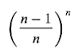
- 當資料量 N 很大（趨近於無窮大）時，根據微積分極限定義：
 代入x = -1
= 0.368
💡 核心結論：每次做 Bootstrap 抽樣，大約會有 1/3 的資料完全沒被抽到（這群資料被稱為 袋外資料，Out-of-Bag, OOB，可用作測試集）；而剩下的 2/3 資料則會被包含在 Bootstrap 樣本中（部分會重複出現）。

2. 實作一：1次線性模型（Degree = 1）與方法對比
課堂中使用 numpy.polyfit(x, y, 1) 來計算 1 次方模型的 β1（斜率）和 β0（截距）。
- Bootstrap 實作：重複跑 20 次試驗（20 Trials）。每次用 resample 抽出一個新的人工資料集，計算一組 β1, β0，最後計算這 20 組係數的樣本標準差（分母為 N-1）。
- 回傳的係數陣列是從最高次方開始排到常數項 : [β1, β0]
- 標準差的Bessel's Correction：
- 因為 np.std() 預設除以 n（總次數），但在統計學上計算估計值的標準誤差（Standard Error）時，我們必須除以 n-1 進行不偏估計。所以助教在代碼中手動做了解決：
修正後標準差 = np.std(array) n/(n-1) 應該要有開根號吧???
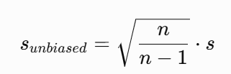
- 結果對比：
  - Bootstrap 算出的標準誤：SE(β1) = ~ 0.00766, SE(β0) = ~ 0.8789
  - 傳統 OLS（smf.ols）公式算出的標準誤：SE(β1) =~ 0.006, SE(β0) = ~ 0.717
核心問題：哪一個估計值比較準？
答案是 Bootstrap 比較準！ 為什麼？
- 傳統 OLS 算標準誤的公式，高度依賴一個假設：「模型設定必須正確」。公式中需要估計雜訊變異數 σ^2，而 σ^2 是由殘差平方和（RSS）算出來的。
- 因為我們已知 MPG 和 Horsepower 的真實關係是非線性的，如果強行用 1 次線性模型去套，模型設定錯誤會導致殘差非常大，進而導致 σ^2 的估計嚴重失真。
- Bootstrap 的優勢：它完全不依賴「模型必須是線性的」這種假設。它是直接對原始數據的分布進行模擬，因此在模型設定錯誤時，Bootstrap 給出的標準誤比傳統公式更可靠。
3. 實作二：2次多項式模型（Degree = 2）
模型升級為二次方模型（Quadratic Fit）：y = β2 x² + β1 x + β0
- 在 Python 中，numpy.polyfit(x, y, 2) 回傳的陣列順序是由高次方到低次方，也就是 [β2, β1, β0]
- 在 smf.ols 中，若要加入二次方項，公式字串要寫成 MPG ~ Horsepower + I(Horsepower2)（使用 I() 函式鎖定運算）。
- 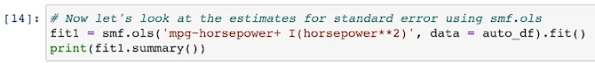
2次模型的結果與發現
- 統計結果：兩者算出來的標準誤（β2, β1, β0）非常接近（例如 SE(β2) 傳統公式算出趨近於 0，Bootstrap 算出來是 8.4 x 10⁻⁵，都極小）。
- 重要觀念：當標準誤（Standard Error）極小時，代表我們非常有信心這個計算出來的係數非常接近真實世界背後的真實參數。
- 為什麼這次兩者這麼接近？ 因為二次方模型已經能夠非常好地擬合（Fit）這組數據的非線性趨勢。既然「模型設定正確」了，傳統 OLS 公式背後的假設就能成立，因此傳統公式算出來的標準誤，就會跟不靠假設的 Bootstrap 估計值高度吻合（Better Correspondence）。
總結
- Bootstrap 的無假設特性：傳統統計公式有許多前提假設（如模型必須正確、誤差項獨立同分布等），一旦現實數據不符合，公式就會失真；而 Bootstrap 藉由電腦算力直接重抽樣，不依賴這些強假設，因而在模型不完美時更具魯棒性（Robust）。
- 多項式回歸的實務：當模型從 1 次方修正到符合數據趨勢的 2 次方時，殘差回歸正常，傳統方法與 Bootstrap 方法的標準誤估計就會收斂一致。
下一堂 recitation 將會進入 Random Forests（隨機森林），到時候這堂課提到的 1/3 袋外資料（OOB）將會扮演非常關鍵的角色。

Np.polyfit()與 LinearRegression() 有什麼不同？
我們前面不是才用 LinearRegression().fit(x, y) 做了一模一樣的事情嗎？為什麼助教在這裡要突然改用 np.polyfit？
特性 | scikit-learn 的 LinearRegression | numpy.polyfit
輸入格式 | 矩陣 X 必須是二維的（2D Array），需要包含你自己手動用 poly() 刻好的所有次方欄位。 | 向量 X 只要是**一維的（1D Array）**原始數據就好。
自動計算 | 模型不會幫你算次方，你丟給它什麼欄位，它就老實算什麼。 | 它在底層會自動幫你把 X 算出 1 次方、2 次方...到你指定的最高次方，不需手動做 QR 分解或轉換。
使用場景 | 適合正規的機器學習流程（有 .predict() 可以直接對測試集丟出預測值）。 | 適合純粹想快速抓出統計係數值，或是做資料科學中的重抽樣實驗（如 Bootstrap）。

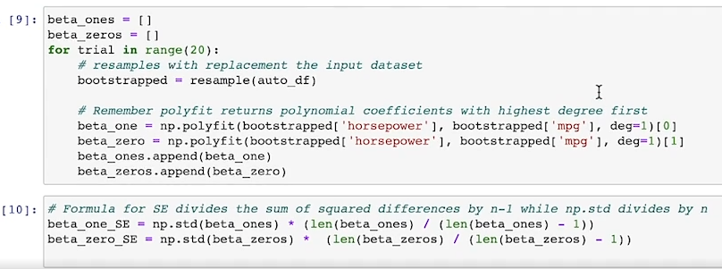
- Cell 10有錯嗎???
beta_one_SE = np.std(beta_ones) * np.sqrt(len(beta_ones) / (len(beta_ones) - 1))

- 透過「有放回的重複抽樣」創造了 20 個平行宇宙（bootstrapped 資料集），並在每個宇宙中算出直線的斜率（β1）與截距（β0），最後統計這些係數的震盪程度，用來當作標準誤差（Standard Error, SE）的估計值。
- 👉 在 bootstrap 裡面：
你算出來的「這些 β 的標準差」 = 就是 Standard Error（SE）

- 自助法抽樣（Bootstrap Resampling）:
  - resample(auto_df)：這是這段 code 的魔法核心。它會對原始的汽車資料集進行有放回的隨機抽樣，直到抽滿跟原始資料一模一樣的筆數。因為是有放回，有些倒楣的汽車數據一筆都沒被抽到，而有些汽車數據則被重複抽到好幾次。

- 用 np.polyfit 快速抓取係數:
  - 這裡重複調用了兩次 np.polyfit(..., deg=1)。
  - np.polyfit 算完 1 次方擬合後會回傳 [斜率, 截距]。
  - 後面加上 [0]：精準劫持第一個元素，也就是該次抽樣的 beta_one (β1)。
  - 後面加上 [1]：精準劫持第二個元素，也就是該次抽樣的 beta_zero (β0)。
  - 最後用 .append() 把這兩個數字各自歸隊存進一開始建立的列表，迴圈跑 20 次。跑完後，beta_ones 裡面就會有 20 個長得稍微不一樣的斜率數字。

- Bessel's Correction計算標準誤差
- np.std（NumPy 的標準差）底層預設的分母是除以 n（在這邊 n=20）。
- 可是統計學在估計母體的標準誤差（Standard Error）時，為了確保估計值是不偏的（Unbiased），分母必須強制除以 n-1（在這邊是 20-1=19）。
- 透過這個公式，就能在不需要任何傳統統計學假設（例如殘差必須符合常態分佈、模型必須完全正確）的前提下，純粹靠數據「自己生出自己」的震盪算出 β1 和β0 的標準誤差！
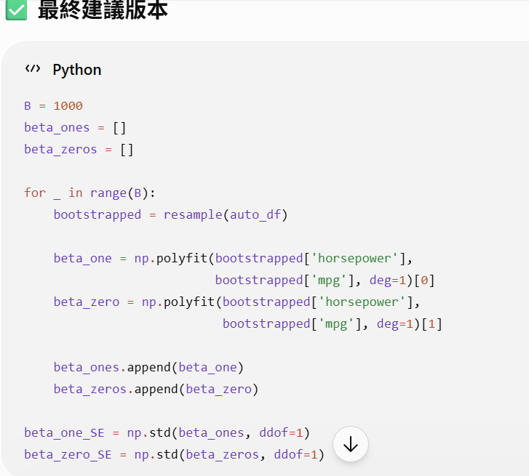
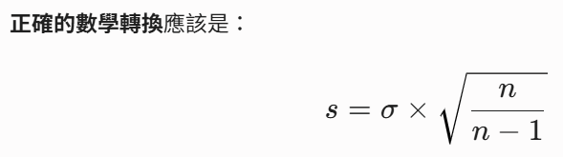
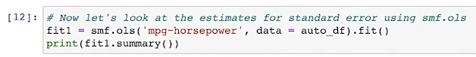
- smf.ols('mpg ~ horsepower', ...)：這是源自於 R 語言風格的 Formula 語法。
  - OLS 的全稱是 Ordinary Least Squares，「普通最小平方法」或「最小二乘法」。
  - ~ 的左邊 mpg 是你的反應變數（y）。
  - ~ 的右邊 horsepower 是你的預測變數（X）。
  - 隱藏亮點：使用這種語法時，statsmodels 會自動幫你加上常數項（Intercept, β0），不需要像 Scikit-learn 那樣擔心有沒有包含截距。
  - ols在計算那條直線的噪音變異數 σ^2 時，它使用的標準統計公式是：
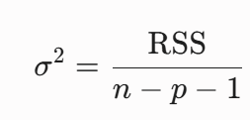
- .fit()：立即對傳入的 auto_df 數據進行擬合，把最完美的 β0 與 β1 計算出來。

注意: 兩個工具計算標準差的公式不同
1. NumPy 的邏輯：我是矩陣運算工具
NumPy 是設計用來做科學計算與線性代數的。當你把一個陣列（Array）丟給 np.std() 時，它純粹把這組資料當成一個「獨立的數學矩陣」。對它來說，你給它的資料就是「全部的資料」了，所以它直接除以總個數 n。
2. Pandas 的邏輯：我是統計與資料分析工具
Pandas 是專門為了資料分析（Data Science）設計的。在實際的資料分析中，我們拿到的資料幾乎都是從更大的母體中「抽樣」出來的樣本（例如：你專案中抽出的 500 筆加州房價）。為了讓這個樣本標準差能精準預估母體，統計學上必須除以 n-1。因此 Pandas 貼心地直接把它設為預設值。

